Team Project
Project Documentation Guidelines
The following is a guide to the sections and indicative content to be included within your project report. Depending on the nature and scope of your project the range of content in each section will vary. Students are encouraged to follow this format to allow for consistent marking across all projects.
It is important to delete this section, and the guidance notes in the document before submission of your report.
Length
The word count for the assignment is
- Year 3: 5,000 to 7,000 words (Individual), 12,000 – 15,000 (team)
- Year 4: 10,000 to 12,000 words.
Formatting
The project documentation should comply with standard project/thesis writing formatting practice, which is:
- Use 12 point font except on front cover
- Use 1.5 line spacing for text, with blank line between paragraphs
- Be consistent in the font use – Time New Roman, Arial or Calibri are acceptable
- Include page numbers on all pages, excluding the cover page
- Each figure and table should have a unique number with label, and be referenced in a list of tables or list of figures as appropriate.
- The left margin should be at least 4cm so as to allow for binding. For double sided printing this should be mirrored on the back page.
- Automatic Heading Styles are set up in this document (Heading 1, 2, 3 4 etc) which can be used. These are automatically linked to the Table of Contents also.
- All headings and subheadings such be numbered using an outline numbering system, i.e. 1.0, 1.1, 1.1.1 etc.
Sample report format follows herewith.



Title of Project | PathFinder
Student Name & Number: | Christopher Costelloe K00233369
Student Name & Number: | Kevin Dunne K00232599
Student Name & Number: | Jekaterina Pavlenko K00224431
Date
Word Count
(excluding appendices)

BSc in Computing
Limerick Institute of Technology (Tipperary)

Certificate of authorship

We hereby certify that this material, which we now submit for assessment on the programme of study leading to the award of BSc in Computing is entirely our own work, and has not been taken for the work of others save and to the extent that such work has been cited and acknowledged within the text.

Name of Candidate: | Christopher Costelloe
Signature of Candidate:

Name of Candidate: | Kevin Dunne
Signature of Candidate:

Name of Candidate: | Jekaterina Pavlenko
Signature of Candidate:

Dated:

Table of contents
List of Figures 6
List of Tables 7
Acknowledgements 8
Abstract 9
1 Introduction 10
2 Problem Definition and Background 10
2.1 Problem definition 10
2.2 Technologies used & Market 11
2.3 Objectives 12
2.4 Project Scope 12
2.5 Deadlines 13
3 Literature Review and Research 13
3.1 Pre-existing Technologies 13
3.2 Upcoming Technologies 15
3.3 Web Hosting 15
3.4 Bluetooth Beacon Technology 17
3.5 NFC Tag Technology 18
3.6 Barcode & QR Code Technology 19
3.6.1 Barcodes 19
3.6.2 QR Codes 20
4 System Design and Configuration 21
4.1 System Architecture 21
4.1.1 Requirements 21
4.1.2 Application mechanics 22
4.1.3 Prototype/Storyboard 23
4.1.4 Architecture Design 24
4.2 Configuration 25
4.2.1 Web Application 25
4.2.2 Android Application 25
5 Example of use 25
6 Testing & Implementation 27
6.1 Quality Assurance Basic Plan 27
6.2 Testing & Test Plan 28
6.2.1 Black-box 28
6.2.2 White-box 28
6.2.3 Test Plan & Test Cases 29
6.3 Debugging 29
6.4 Implementation 29
6.5 Accomplishments 30
6.5.1 Expected Project Results 30
6.6 Improvement ideas 31
7 Critical analysis 31
8 Conclusions 32
9 Bibliography 32
10 References 32
11 Appendices 34
11.1 Appendix A 34
11.2 Appendix B 37
11.3 Appendix C 39
11.4 Appendix D 40
11.5 Student 1 Reflection 43
11.6 Student 2 Reflection 43
11.7 Student 3 Reflection 43
11.8 Code (if appropriate) 44
11.9 Schematics (if appropriate) 44
11.10 User manual (where appropriate) 44

List of Figures
Figure 1. Gantt Chart. 13
Figure 2. Phase 1, 2 and 3 features. 35
Figure 3. The Phase 3 functions and their breakdowns. 35
Figure 4. Phase 3 and 4 breakdown and final deadlines. 36
Figure 5. Visual representation of our schedule deadlines. 36
Figure 6. Visual representation of our schedule deadlines. 37
Figure 7. Feature Breakdown including Sprints. 37
Figure 8. Part 1 of the FBS. 38
Figure 9. Part 2 of the FBS. 38
Figure 10. Part 3 of the FBS. 39

Fix the figure numbers and the table

List of Tables
Table 1. Use Case/Storyboard. 25
Table 2. Test Plan. 29
Table 3. Expected Deliverables. 30

Acknowledgements
Express your gratitude to the person or institution for the valuable contributions in the implementation of the project
“I would like to express our special thanks of gratitude to (position & name) as well as (position & name), who gave us the golden opportunity to do this wonderful project on the topic Indoor Navigation Software, which also helped us in doing….”
- Family & family members, especially Christopher’s wife for giving the idea of the project
- Teachers
- Group members
CCO

Abstract
150-200 word paragraph that provides readers with a quick overview of the project. It should express the central idea and key points. Also, it should suggest applications of the project.
25% of their space on the purpose and importance of the research (Introduction)
25% of their space on what you did (Methods)
35% of their space on what you found (Results)
15% of their space on the implications of the research
CCO

Introduction
PathFinder is an application (Android Phone or Tablet), that allows a user to find the way around supported buildings and areas, so if a user entered into a building, such as LIT, an app could be downloaded and person will instantly have an access to an interactive map of LIT, which has the ability to display all room names, numbers and other specific information about the room, such as timetables etc. In other words, PathFinder is a navigation software for buildings and path trails. An app displays different room locations on a map and a path, which the user can follow to reach the intended room, following the optimal path. The implementation of the indoor navigation system is to have specific sensors laid throughout building, which are going to interact with user’s device to track user’s location in the building and based on the provided information be able to set a path.
The development of PathFinder involves different technologies: Azure for the projects database and web hosting needs, Bluetooth Beacon, NFC tags, QR Code and Barcode technology for the hardware needs.
The major target of usage will be colleges, hospitals, airports. Buildings, where people usually most struggle to orientate themselves in. The main goal to achieve not just cheap & cheerful version of indoor GPS system for people, but also make it precise & efficient one as much as possible, by using mix of technologies mentioned above.

Problem Definition and Background
The 2nd chapter describes, along with problem definition & background, the project main objectives, what have to be done to achieve the expected result, the project scope and a plan for the project timeline implementation based on Gantt chart.

Problem definition
As everyone knows, GPS can’t be used in indoor environments, because signals from satellites do not move easily through solid objects such as brick, metal, stones & wood. All these materials usually used for making buildings & make it very difficult for GPS signals to pinpoint person’s location accurately indoors. The solution is IPS – Indoor Positioning System, which is the next generation of positioning technology helps to beat limitations of GPS. Indoor Navigations System technologies are being developed by Google, Microsoft, Nokia etc.

Technologies used & Market
Based on the research of current indoor GPS navigation systems on the market to better understand advantages & disadvantages of products and how to make PathFinder system better than the existing systems on the market right now by trying to implement different solutions and also by developing a system that is lower cost than bigger companies, which charge an extremely large amount of money.
There are several types of wireless technologies are used for IPS: WLAN, Wireless Bluetooth techniques (used for PathFinder system), Infrared (IR) techniques, Ultra-wideband (UWB), Ultrasonic system & Cellular based techniques etc.
List of brief descriptions of some technology that most commonly are used to solve the indoor navigation system:
- WLAN – wireless local area network with added a location server. Range is 3-30m. Technology using RSS help, which is another technology that collects updates to renew system every few seconds.
- Infrared (IR) techniques – using infrared light pulses, like in TV remotes, to locate the objects inside. It has a simple structure, low cost and quite high accuracy. In every room installed IR receiver device and when IR tag pulses – it received by device. Minus of this technology that it cannot pass through obstacles and has short data transmission distance.
- Ultra-wideband (UWB) – a new communication technology sending and receiving nanosecond pulses to transfer the data. This technology gives precise indoor positioning, it has a low power consumption, high security & low complexity. Used a lot in military.
- Ultrasonic system – using triangulation positioning algorithm to locate objects. It offers a high accuracy, simple structure, but needs a huge hardware infrastructure investment that will cost a lot.
- Cellular based techniques – is using a global system mobile cellular network to locate mobile clients. Range 50 – 200m, depends on infrastructure – if there is several base stations with RSS or one station with strong RSS.
There are a few companies that on a market that offering Indoor Positioning solutions:
Infsoft company from Germany, which provides leading indoor GPS navigation products such as Indoor Positioning, Tracking & Analytics solutions for businesses, is used to map out warehouses, to track in which zones of store customers spent most of the time for future store optimization & to guide automated vehicles in the same warehouses. Infsoft company is using technologies such as: Wi-Fi, Bluetooth beacons, Ultra-wideband, RFID.
Eliko company from Estonia, also provides solutions for such industries as Biomedical, Logistics & Warehouse, Manufacturing industries. Eliko is using Ultra-wideband technology as well. Also, company has an indoor & outdoor positioning solutions and tracking systems. At company page, researches are posted, that have been done, how everything works and even pricing for products.

Objectives
This project aims to create an interactive map for any building using an extremely low cut budget but will be able to deliver an effective and easy to use application.
The idea behind this app is to make something that is simple to use, simple to maintain and update, and easy for everybody to work with.

Project Scope
The Product scope requires:
- a website that organizations can register and log onto, user will be able to upload, delete, and edit new Maps of their buildings with information on each checkpoint.
- a database that will store information on both the website and application and the ability to manipulate both from each.
- (for the application) that the user will be able to use the application to download a map from any listed buildings, the user will scan a QR code to check a current location, this will be a checkpoint, the user will then select another checkpoint on the map and an icon or waypoint will be displayed to user to guide to the destination.
- hardware supplies – Bluetooth beacons, NFC tags ordered and QR codes & Barcodes generated for precise user’s location on the map, then based on provided data to set up the path to the destination.

Deadlines
Deadlines and roles have been laid out in specified Gantt chart, which displays all features and their breakdown and including the man-hour’s each section will take.
This is the initial page of team’s Gantt Chart which display all the phases of our overall project and there deadlines which are specifically highlighted in yellow, on the right side of the screenshot is the visual representation of our overall schedule and deadlines, the full Gant Chart is viewable in Appendix A.
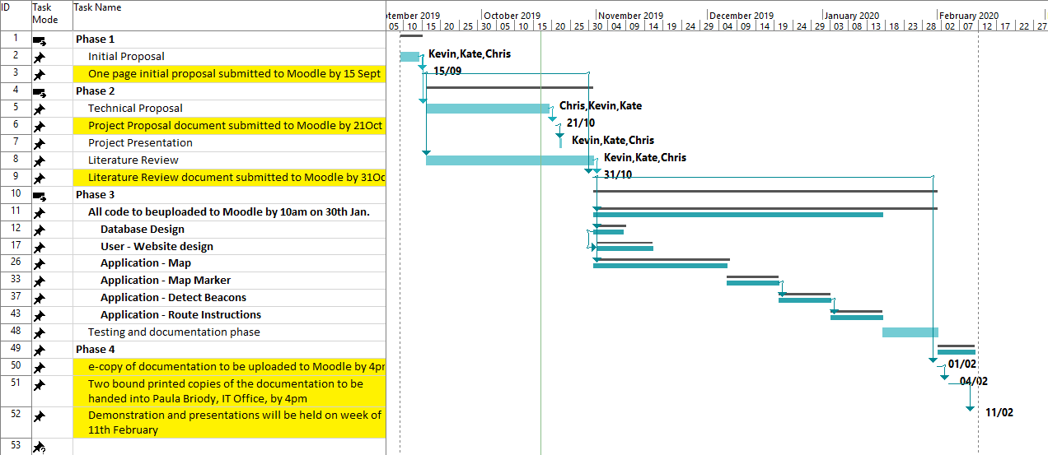
Figure 1. Gantt Chart.
The full feature breakdown structure and the sprints in excel format are available in Appendix B.

Literature Review and Research

Pre-existing Technologies
The first thing that was researched was about the different companies that have implemented or are planning to implement indoor GPS navigation and companies who are doing research and are inventing new tools to make implementing this technology easier.
The first company that was researched was Infsoft, which was one of the leading indoor GPS navigation companies around. The research, that was done, helped to explain and understand exactly how this company was using their software in conjunction with hardware to map out their warehouses. (Infsoft.com, 2019)
The hardware that was used was a Bluetooth beacon to setup positions inside a building injunction with Wi-Fi to have a constant signal which can be used, also Infsoft Locator Nodes and Infsoft Locator Tags were created, which actually allow to track people and assets in real time in any of their buildings. (Infsoft.com, 2019)
The most interesting aspect of indoor navigation is the absolutely amazing amount of versatility, which offers different people and companies through tracking different machines, packages, people in factories and collecting analytical data to help optimise their system and work output, one of the most surprising things, that was discovered about this, was - how it is possible to track different customers inside a shop, that has a specific layout, to see how much each person spent at one zone or what path they choose to take. Information like this has an immense value to business owners, in example, to help to optimise the store to make more money. (Infsoft.com, 2019)
One of the most important factors in indoor GPS navigation was the essential need for reliance, one important factor – showcases, what would happen if multiple vehicles, that were all automated and guided by an indoor GPS navigation system, were not efficient and caused different vehicles to run into each other, causing untold amounts of damage. This is a very real and serious situation and has the potential to be quite dangerous for people as well, because of congestion in buildings or vehicles moving around that had incorrect sensors that might crash into a person. All these factors must be taken into account when designing such system.
GiPStech is another leading indoor navigation technology company, that has been paving the way for a variety of new advancements, involving indoor navigation. This company has created a new way of creating an indoor navigation system by using an infrastructure free, which involves the use of no Bluetooth beacons. This is a massive step forward in indoor navigation, because most companies use standard or specialized beacons as the focal point of their entire indoor navigation system and because the next generation of indoor GPS navigation seems to be moving away from this and just using Wi-Fi signals and the geomagnetic signals that were already installed in the location as the data sources to accurately pinpoint the location inside the building. (GiPStech, 2019)

Upcoming Technologies
The constant advancement of indoor GPS navigation technology has been steadily increasing as the incredible importance of this technology grows, increasing more essential in everyday life. The benefits this technology offers is incredible and because it is used in so many applications, which nearly all ask for or require a GPS location. The need for a more sophisticated GPS location based software has been steadily increasing, which has seen a variety of companies around the world, which invest heavily into sophisticated and low tech solutions, such as Google, Apple and Infsoft.
The future of indoor GPS navigation is constantly changing and evolving. One of the biggest reason for the push is customer convenience. The customer wants to find the way around a building quickly and easily, but this can be enhanced by connecting navigation apps with different retail shops inside a shopping centre. For example, the next logical step is for a person, who is looking for an item online, then connects that to their GPS navigation application and be delivered a real time path inside a building to that item - this is the future of indoor navigation. The technology of such type of delivery does not exist in just one form, but many forms such as Bluetooth navigation in conjunction with real time location technology all of these will come together in the future to deliver this incredible accurate technology. (Directionsmag.com, 2019)

Web Hosting
The web hosting companies, that were researched, were Amazon Web Services and Azure Hosting. The first company was Amazon Web Services, which offered a free 12 month subscriptions on multiple different services such as database, web hosting etc., which the project need for a variety of roles.
The first thing, that was looked, were the differences between the 2 different services just to check - did either have any large negative service that would impact the project and the research concluded, that both companies offered quite similar services with negligible differences.
Azure hosting is the main hosting company, which will be used for the project’s database and web hosting needs in the application. The research concluded, that students actually have a free 12 month subscription, because the college created students accounts with Microsoft, which allows the students to use all Microsoft applications, including Azure, which is an incredible benefit to the project, because of the wide array of options it offers, allowing the project more flexibility, also saves money by not needing to use other hosting applications which depending on the company are either lower quality hosting sites or reliable and good hosting companies, which charge an extraordinary amount of money and what the project could not afford.
Amazon Webserver offers very good services, but the reason Azure Hosting was chosen is because the research, that was undertaken, lead to the conclusion that Azure offers the best mix of these services compared to the other hosting companies. List of advantages includes:
- Availability
- Azure Software Development Kit
- Scalability and flexibility
- Stability
- Recovery
- Integration Tools
The Azure application allows the use of a variety of different development environments such as Eclipse, Visual Studio, NetBeans, MySQL and many more. This offers to the project an immense amount of flexibility, because all these applications have a variety of tools, which can be used for a great effect in the project. The Azure web hosting technology requires .net framework experience, which is problematic, because it is not taught, but the benefits of being able to using other IDEs is because Azure is cross-platform, friendly.
The Azure application can be used in conjunction with GitHub to pull new code from the project repositories and used to update both the web front-end and database back-end of the project, which offers a flexible and stable backup and upload centre.
Azure hosting had a nice mix of all these features and even more that helped to realise that this is the best choice for the project. (TechRepublic, 2019)

Bluetooth Beacon Technology
Bluetooth Technology was begun in 1989 by Dr. Nils Rydbeck and Dr. Johan Ullman. First goal was to make wireless headsets. After that each generation of Bluetooth was adding new features to it.
Bluetooth Beacons is hardware data transmitters at short-wavelength radio waves, from 2.4 to 2.485 GHz, between two and more devices that are near and performing actions when a device is close to the beacon. This technology usually used to determine physical location & to respond as a location-based action to a device. Bluetooth Beacons come in variety of forms, from coin-size cell to USB stick.
The idea how Bluetooth beacon works:
- Information broadcasted from a beacon
- Phone receives information and sends to backend systems
- Analytics backend systems receive and process the data
- Notification is delivered over network to mobile application
From Bluetooth 4.0 version, it is possible one-way communication, when Bluetooth device just transfer the data, but not listen for it. Also, it works with less impact on the battery life and with good extended precision.
Bluetooth Beacons come with variety of powering design as well: battery powered, which the project is going to use, & USB powered, which are good for a long-term installation option. As the project is going to use battery powered beacons then the manufacturer specifications related to power consumption, interval transmit power, also must be in count approximate frequency of usage and think by what kind of phones, it might be use. Battery powered beacons life range is about from 1 month to 2 years.
There is two most popular version of this technology – 4.2 and 5. Bluetooth 5 improved version, of course, with more speed, which is 2X times higher than at 4.2 - 2 Mbps against 1 Mbps & with more range, which is 4X times higher – till 40 metres indoor range. Power consumptions of Bluetooth is less than previous version & battery life is longer. Also, capacity of message larger, 255 bytes against 31 bytes.
The project plan is to use about 2-3 beacons per building, just as checkpoints of user’s location.
Mobile Device support – Android and iOS do not do it natively and a generic application is needed for that.
Other usage of the beacons is location-based advertising, healthcare (in-home monitoring), customer data collecting for improving customer loyalty with special offers, payments accepting etc.

NFC Tag Technology
NFC tags (abbreviation for Near Field Communication) are basically, small stickers, of round or square shape and the size of the coin, with an integrated circuit that able to store data and transfer it between NFC-enabled devices such as smartphones and tablets. In wireless world, NFC’s closest relative is RFID, which stands for Radio Frequency Identification. NFC readers work at approximately 10 cm of maximum range.
NFC tags are passive, because they don’t have any power source. They take power from the device that reads them by using magnetic induction. When reader-device gets close enough to an NFC tag, it energizes the tag and then transfer the data from the tag. There is always some power lost during the transmission, but it is usually still enough to power the NFC tag. They ‘steal’ a bit a power battery of the phone to kick in, basically.
NFC tags can be with different memory capacities. It’s possible to store a telephone number or URL (web address), also there is opportunity to add the protection – NFC tags can be locked, once data has been written, it cannot be changed. They can be re-encoded a few times before they are locked forever. During the research, 5 different types of tags were found, with different capacities and data transfer speed:
Type 1 & 2 store from 48 bytes up to 2 kilobytes of data and communication speed is up to 106 Kbit/s. These types of tags can be rewritten several times and also be permanently locked, so no one could apply any changes to data. These tags able to store something short like a website URL – a simple piece of information.
Type 1 is used for read-only applications, business cards etc. Type 2 is more popular, because offers more functionality and has relatively cheap price. Type 2 used for low-value transactions, event tickets, URL redirects etc.
Type 3 stores up to 32 KB and communication speed is up to 212 Kbit/s. It provides a wide range of the functionality, but price is quite high. These types can be written only once and has the lack of security. It used for more complicated applications such as E-tickets, electronic ID, membership cards, etc. It is very widely used in Asia, because it is Japanese innovation.
Type 4 has the same capacity, but speed is up to 424 Kbit/s and offers most of the flexibility and memory but has high price for it. Also, it provides a good security.
Type 5 is used for library books, products and ticketing applications.
It’s a quick and efficient way to push any information to your phone. Also, they are very cheap to make, maintain and can be used for wide range of apps.

Barcode & QR Code Technology

Barcodes
“The barcode was invented by Norman Joseph Woodland and Bernard Silver and patented in the US in 1951. The invention was based on Morse code that was extended to thin and thick bars.” (En.wikipedia.org, 2019)
“Barcodes became commercially successful when they were used to automate supermarket checkout systems, a task for which they have become almost universal. Their use has spread to many other tasks that are generically referred to as automatic identification and data capture (AIDC)” (En.wikipedia.org, 2019)
“GS1”is a company that provides barcodes to organisations and has a comprehensive list of steps that can be followed to obtain a barcode (see link above). A barcode consists of a prefix of 2 or 3 characters and a company number, which can be assigned to an organisation by GS1 (and other companies). Once these are assigned, then a decision has to be made as to the type of barcode to be used, from a simple code, to one that can contain URL information, from codes to be used at a POS device (must support omni-directional scanning), warehouse (larger size codes for distribution scanning) or healthcare items (omni-direction scanning not required), all require different types of barcodes. (Gs1.org, 2019)
The project will have the capability of be using bar-codes that have been generated by either a web-service or program. The project will be using a variety of options when it comes to enable the generation of barcodes for use within the project / application, to allow the users of the application to identify where they are. (Windows Report | Error-free Tech Life, 2019)
Since the generated barcodes are compliant with current standards, any standard or conventional barcode reader will be able to read the generated barcode. The options that were researched has shown that it is possible to install onto an Android Phone, an App that can read both Barcodes and QR codes, and this can be used to test the readability of the barcodes that have generated. (wikiHow, 2019)

QR Codes
QR code (abbreviated from Quick Response code) is the trademark for a type of matrix barcode (or two-dimensional barcode) first designed in 1994 for the automotive industry in Japan. A barcode is a machine-readable optical label that contains information about the item to which it is attached. In practice, QR codes often contain data for a locator, identifier, or tracker that points to a website or application. A QR code uses four standardized encoding modes (numeric, alphanumeric, byte/binary, and kanji) to store data efficiently. (En.wikipedia.org, 2019)
QR Codes are now very common and can be found almost anywhere and nearly all smartphones can scan a QR Code and act on the contents of the QR Code. From bringing a user to a site, allowing for payments, for virtual store shopping, website and Wi-Fi network logins to the ability to have QR codes engraved on headstones so that visitors to a gravesite can find out about who was buried there and possibly, information about their life.
Since QR Codes are now so common, it is nearly mandatory for the project to be able to read QR codes as they are very easy to generate, the same websites and applications for barcodes can be used for QR Codes. Users of the project / application may be more familiar with scanning in QR Codes than Barcodes, but the project / application will support both methods, as well as Bluetooth beacons and NFC Tags.

System Design and Configuration

System Architecture

Requirements
In order to implement this system, the project requires:
- Azure Hosting of the Database.
- Web Hosting for the users / companies – show info on the production for users and to allow companies to upload their data and waypoints.
- Android App will be the main user interface and will consist of
  - Landing screen with information about application.
  - Ability to capture where the user is and what maps / waypoints are needed.
  - Allows user to select where they need to go using a dropdown or icon on the map.
  - Show instructions on “how to get there” form where the user currently is using an icon or text popups.
  - (Optional) Message to inform user when they have reached their Destination and potentially display information on their destination.
This is a high-level diagram (at Figure 1 shown below) showing cloud with database server, linked to a network (for users to check in at home / companies to upload data), business place/college/hospital and user connecting to database to get required details to find the route to where they need to go.
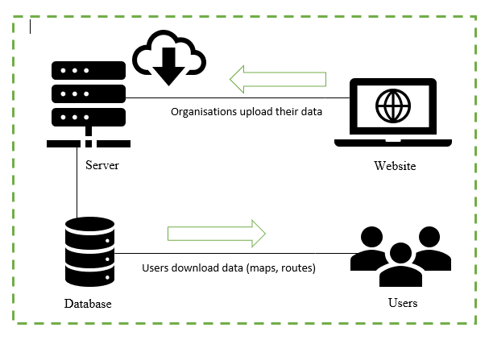
Figure 2. System architecture/topology.

Application mechanics
The proposed solution has two different interfaces for the users and the companies. In the storyboard below, both are shown.
The web site will allow the user to preview what the application can do. For business, there is an option to register to use the application / database. This will be used to contact the company and setup required information. Companies, once approved, can then login and setup their maps and waypoints. A “Contact Us” page will be available for all general enquiries on the application.
For the Android Application, one launched, the user will have simple instructions on how to use the app. The user then obtains the company information (maps and waypoints) by either Bluetooth, NFC tags, barcodes or QR codes. Once done the map is then presented to the user with a drop-down allowing the user to select where they would like to go. The list of instructions is then generated and show to the user. The user can obtain updates along the way, either by Bluetooth, NFC tags or by scanning other Barcodes and QR codes.

Prototype/Storyboard
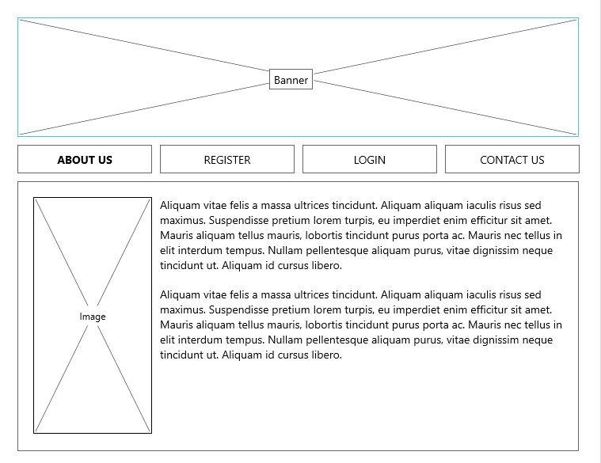
Figure 3. Landing Page.
This is the webpage for the user/organization so that users are introduced to an application and contains essential information about the product and what to do, see Appendix C for all website screenshots.

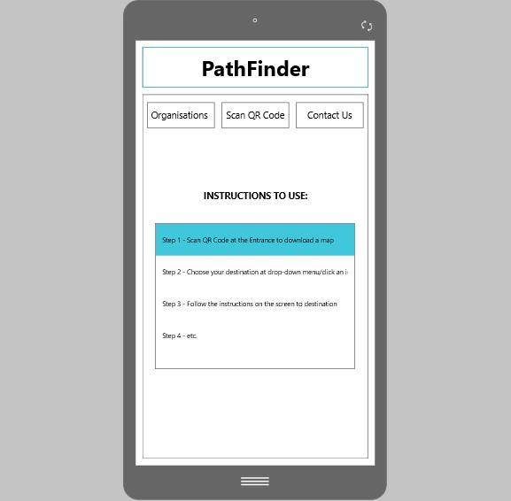
Figure 4. Android application landing page.
This is the instructions that will be displayed to the user to help them understand how to use the application, all other screenshots that display added functions and features of the mobile application are available in Appendix D.

Architecture Design
Azure hosting will be used as this is, what research has shown, the best suits for the current requirements. This hosting will be for the database and the website. This is one half of our solution and the other will make use of Android phones / tablets.
The Apple systems are not considered at this time as there is insufficient project time available to support two Application developments.
Bluetooth beacons and NFC tags will be supported so that the application can be more automated and easier for the users of the application.
Barcodes and QR codes can also be used but these need to be scanned in by the user and increase the complexity of the application use. It would be easier for the user to use either Bluetooth beacons or NFC tags, but all methods can be used, and they can all be available for a business (mix and match approach).
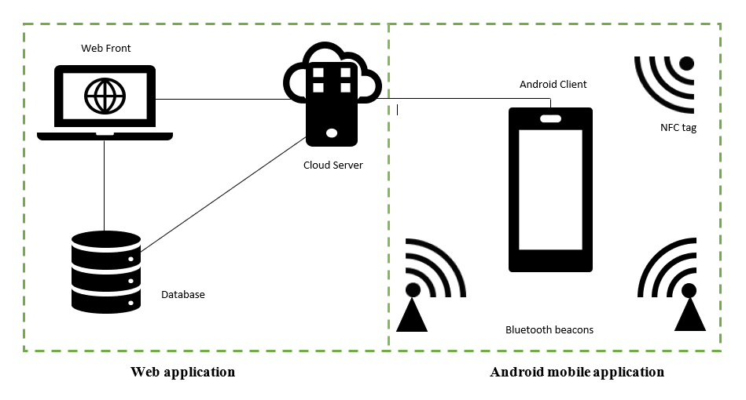
Figure 5. System architecture/topology.

Configuration

Web Application

Database Design
This is our database ERD diagram that was used for our project database, this ERD was designed using the MySQL Workbench ERD diagram tool, this helped our team to recreate a variety of different iterations for our team’s database quickly and efficiently, the diagram below is the final database diagram iteration.
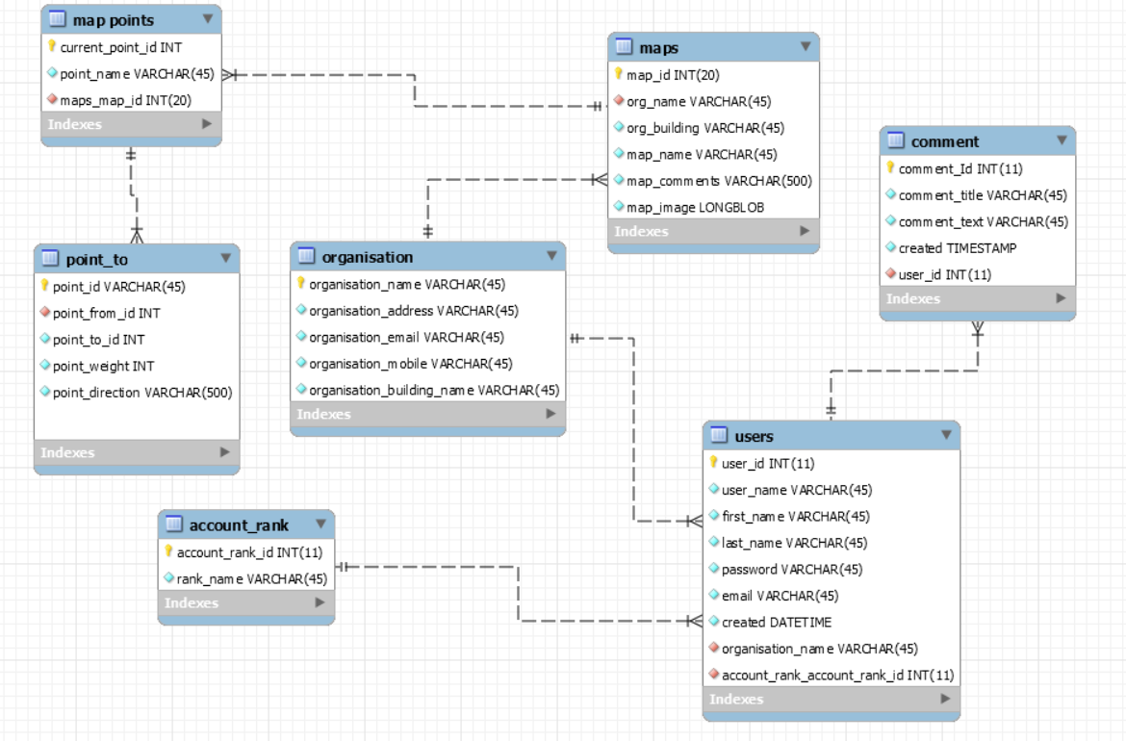
Figure 2 erd diagram of our database

Azure Hosting.
The Azure Cloud Computing service has the ability to host website’s for free to student and this is the application we used to host out website “https://pathsearcher.azurewebsites.net/”, the process involved in setting this up required our team to setup a resource group called Path, this resource group puts all the database and websites our group used under the one umbrella, once this has been setup our group could now create a website.
Figure 3 Azure resource group path

RemoteMysql
The Azure database software had a large learning curve and used an incompatible SQL database that our group was not familiar with, this lead us to the decision to change our database hosting site to a more easier to use one which lead us to RemoteMySQL.

This is a free database hosting company that we used to create our database, there are also some downsides to using this application compared to using the Azure SQL database and that is the speed that we can access this database, because it is a free database it has very limited ability to handle multiple interactions simultaneously or even just one person using the mobile application to rapidly access the database repeatable, this is a large downside but because it is free our group has tolerated this downside and because we have the code for our SQL database we could rapidly switch to a more advanced database for better speed.

The downside of this is problematic at times during our team’s testing phase which is why our group used a local database using MySQL workbench which allowed us to rapidly test our application without any delays which speed up our testing phase.

phpMyAdmin
The database management tool that our group used was phpMyAdmin, this tool was something we have extensive familiarity with and was a bonus to our project for this reason, phpMyAdmin is a very simple and easy to use application which allowed our group to very quickly setup an online database which our group used to access through our IDE Eclipse for local development and through our Azure website, its ease of use allowed us to quickly upload a pre-configured database by either entering through the console or uploading an SQL file directly.
This application also allowed our group to quickly and efficiently access and view our records to test and maintain our data in a variety of ways.
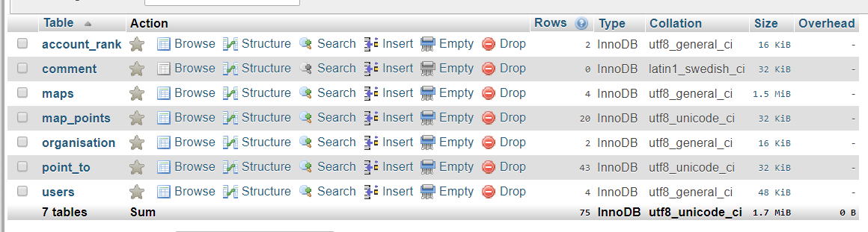
Figure 4 phpmyadmin displaying sql tables

Postman
The Postman application is an google chrome application that can be used to test HTTPS API’s for use in a variety of ways, our group heavily used this application to test our JSON RESTful web service API’s to see how they worked and interacted and to see if our JSON data was being delivered as our group had specified and to see it displayed in the exact way we had intended.
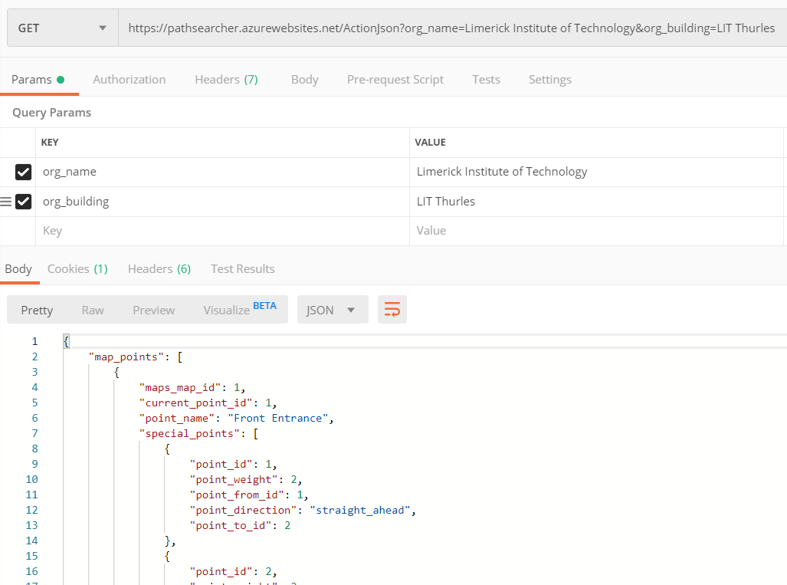
Figure 5 postman returning json request

Maps & Points Setup
The Maps and Points setup in our project is the single most important factor and was one of more difficult to develop and implement, the idea behind the maps and points was to have two tables in a database called “map_points” and one called “points_to”, the first table map_points needed to hold the 3 pieces of information the a random int number, the name of that point and the map that connects to that point, this three pieces of information are of vital important because it identifies the point identity and which organisation this point connects to by the map id.
The point_to table is of vital important to our project because it is the second most important piece of information that connects the individual points of our map, it holds 5 pieces of information which is the point_id, from_point_id, point_to, point_direction and point_weight, these 5 pieces of information map up the strings that connect each point on our map and without them our project would be incapable of functioning.

The actual setting up of the map requires the user to select a from and a to destination and this is made easy by our teams idea of using drop downs to help the user to select where they are going from and going to instead of our original idea of using integers which would be confusing, the only thing that the user would have to input is the weight to get to a location and also a direction which has been made easy by the use of another drop down table which has 5 pre-existing directions to choose from.

Website
The pathsearcher website is the cornerstone of our team project because of how it is used to create and handle our map information, one of the most important factors of our team project is how we upload a graphical map of our building, this graphical map contains the point names so the user has an easy idea how where each point is on a map for ease of us.
The second most important use of our team project website is the creation of the points which include the point name and the points drop downs that help guide the user in creating the map, this is one of the most important pieces of our group website because without it our project would not be able to function without these crucial pieces of information.

The pathsearcher website has 2 RESTful Web API’s that are crucial because they connect the android mobile application to the RemoteMySQL SQL database, the way both of these web APIs work is by accessing the SQL database and pulling information from the map_points, point_to, maps, and organisation tables, the information from these tables are then formatted into a JSON object and organised into JSON objects with embedded arrays to hold the information in such a specific way that it connects all the points together as seen in the figure below which shows how 1 point location is connected to multiple other points on map.
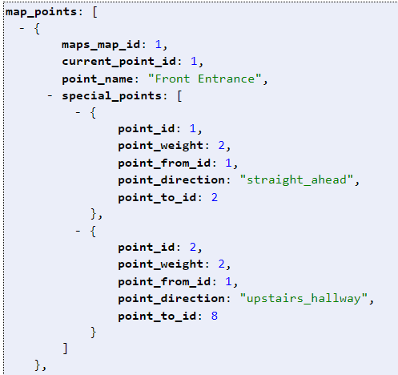
Figure 6 nested JSON array displaying connected points

Android Application

SQLite Database
The android application uses SQLite database library as our local storage for all our information from the RemoteMySQL database, this information is first accesses through the website using a RESTful Web API that pulls information in a JSON object and this information is then formatted multiple ways and stored in our local SQLite database called “Maps”,

This local database is used throughout our application to display the different organisations that they user can select which will then display map information specific to the Organization and the Building name of that organisation they have chosen.
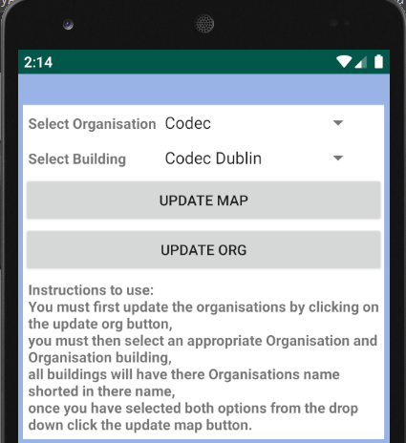
Figure 7 drop downs showing information pulled from the website through the use of a REST API
- QR & Barcode Scanner
- Building the path

Example of use
Solution can be used in any building and areas, where the app is supported. User can download the application and use an interactive map of the current building to navigate around it, just simply scanning QR or Barcode provided around the building or area, which must show the current user’s position. Based on this information and picking the desirable destination from the drop-list at the Android App, then App should provide navigation instructions to reach the destination.
In practice, it should be very useful in buildings as colleges, hospitals or airports, because it is easy to generate QR and Barcodes, to implement the app and use it, and also related to pricing of the whole project – it is very low.
Due to time constraints, we managed to map the building only using the QR & Barcodes and by using Use Cases, the basic application set up and instructions, how to use it in real world, will be provided below:
Table 1. Use Case/Storyboard.
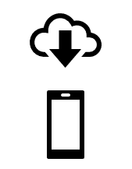  - Download the App | 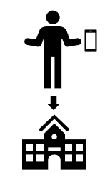  - Walk into the building
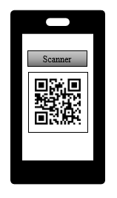  - Scan QR Code at entrance | 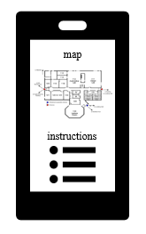  - Get an map, pick the destination
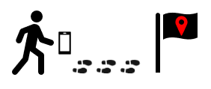  - Follow the instructions | 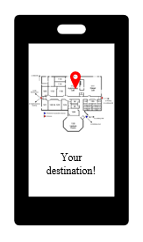  - Get a notification, that the destination is reached

Testing & Implementation

Quality Assurance Basic Plan
As the primary purpose of this software is to get a user from one point on a map to another point on the map, we have to make sure that the user is urged to follow the suggested path while taking care of their surroundings (walking on paths, crossing roads with due diligence, etc.)
In order to achieve this and ensure the quality of our software, testing of all sprint aspects must be done by all team members to ensure that there are no issues with the software, the results and the maps, instructions that are shown to the user, if the software is not of high enough quality, then the following is possible:
Web application:
- Site not available for users
- Site not allowing users to login / logout
- Site not updating companies’ data correctly
- Site not responding to app API requests
Detailed testing of each sprint and the system components will ensure that the site is working and responding as needed.
Android Application:
- Not launching correctly
- Does not scan (barcodes or QR Codes)
- Bluetooth and / or NFC not working
- Incorrect Maps / Way Points downloaded
- Bad path to destination generated (long way instead of best way)
- App not updating correctly
Detailed testing of each sprint by all team members will ensure that the app was developed as needed and that all features work as per expectations.

Testing & Test Plan
Testing is important part of Software Development Life Cycle, because it increases software quality, discovering errors and bugs, when the whole development process is completed. Testing’s goal is to ensure that the software behave as expected by giving wanted result/output. Some errors might be small and not that important, others can cause real damage like financial loss or be a life threat. There is different types of testing that used in SDLC, that covers different parts of the product. Most known are Black-box and White-box, which also have number of levels of software testing.
Different types and levels of testing will be applied to the PathFinder project to see does it meet basic user requirements and, hopefully, to improve the level of the product quality, in general.

Black-box
This method is used to test the software without knowledge of internal structure of it or knowledge of the coding. The method is done by testers, usually. Testing is applicable on higher levels of testing and mostly covers functional and external testing.
Techniques that will be used for the project are: Boundary Value Analysis and Equivalence Partitioning and Error Guessing, which will be applied in the Test Plan.
Types of Black Box Testing that might be useful are mostly major types of Functional Testing part, which are: Integration Testing, System Testing, Regression Testing, User Acceptance Testing, and some types of Non-Functional Testing such as: Usability Testing, Performance Testing, Compatibility Testing.
System Testing
Acceptance Testing
……
CCO

White-box
White-box method of testing requires the knowledge of internal structure of the system and programming skills. This method is done by software developers. Testing is applicable on low level of testing. White-box testing means structural testing.
Find the test case that is going to break the code
Unit Testing
Integration Testing
…
CCO

Test Plan & Test Cases
Table 2. Test Plan.
Test Case | Description | Class | Input | Expected Result | Actual Result | Action

Debugging
The process of fixing the errors in the code by software developers. To prevent the system behave unexpectedly or even crash. Programmers can trace the program execution step-by -step and most of programming development environments provide a debugger for checking the code errors.
General the debugging process that team used during the project development:
- Found an error
- Trace it down using debugger tool
- Fixed it
- Run the project again to verify that it gives expected output

Implementation
The Development Methodology that the group have decided to implement is the Sprint Agile development module, the reason, why is this methodology, because since the course have been started that development methodology has been constantly praised and this is, also, becoming the industry standard.
This has led to the further research and study the agile module over the previous years and to base the majority of the course projects around this method which has now become as second nature, this is the reason this development methodology was chosen to use for the final project.
Using this Methodology enables to do quick developments each week e.g. sprints, to show progress of the project, to test and verify what each member of the team is doing and what requirement are needed, to keep the group focused on getting small bits done quickly so that the project proceeds and can be delivered in good time and to a high standard.

Accomplishments
In order to determine the success of the project, the following goals should be achieved:
- The user can find the web site and learn vital information about the application.
- A company can register with the site and can login.
- The company can upload maps and select waypoints on a map.
- The user can view company maps and waypoint/checkpoints on a browser.
- The user can sideload the app onto a phone and use the maps and waypoint/checkpoint to get to a selected destination.
The Expected Deliverables Results, which are listed at the Table 3 below, must help for better evaluation and analysis of the whole project accomplishment level.

Expected Project Results
The expected deliverables for the project that were planned as follows:
Table 3. Expected Deliverables.
Working website
Delivery | Done
User can find and use the web site
Companies can register for use of the website
Companies can log into the site, update their information, map and way points and logout
Anybody can send on a query regarding the site and application
Hosted Database
Storage of company data
Storage of maps
Storage of waypoints
Android Application
Launch screen
Ability to capture where the user is (Bluetooth beacons, NFC tags, Barcodes, QR Codes)
Show maps and places user can navigate to
List of instructions / steps on how to get to the destination

Conclusion……., based on this table

Improvement ideas

Critical analysis
Achievements against the original objectives
Difficulties were encountered CCO
Lessons learned
The project follow the planned timeline
Timeline usefulness
Key findings to help to work on the project

Conclusions

Bibliography
Web sources were used to design, develop and test the project, all references are listed in the next chapter.

References
Infsoft.com. (2019). Indoor Navigation, Indoor Positioning and Indoor Tracking by Infsoft. [online] Available at: https://www.infsoft.com/ [Accessed 30 Sep. 2019].
Wikipedia. (2019). Bluetooth low energy beacon. [ONLINE] Available at: https://en.wikipedia.org/wiki/Bluetooth_low_energy_beacon. [Accessed 5 October 2019].
RF Wireless World. (2019). Difference between Bluetooth 5 and Bluetooth 4.2. [ONLINE] Available at: https://www.rfwireless-world.com/Terminology/Bluetooth-5-vs-bluetooth-5-1.html. [Accessed 5 October 2019].
Amar Info Tech. (2019). Differences Between Bluetooth 5 vs 4.2. [ONLINE] Available at: https://www.amarinfotech.com/differences-comparisons-bluetooth-5-vs-4-2.html. [Accessed 5 October 2019].
TechRepublic. (2019). 10 reasons to use Azure for your cloud apps. [online] Available at: https://www.techrepublic.com/blog/10-things/10-reasons-to-use-azure-for-your-cloud-apps/ [Accessed 7 Oct. 2019].
OTAVA. (2019). AWS vs Azure: Key differences | OTAVA. [online] Available at: https://www.otava.com/reference/aws-vs-azure-key-differences/ [Accessed 7 Oct. 2019].
Howstuffworks. (2012). What's an NFC tag?. [ONLINE] Available at: https://electronics.howstuffworks.com/nfc-tag1.htm. [Accessed 28 October 2019].
AndroidAuthority. (2018). All you need to know about NFC Tags. [ONLINE] Available at: https://www.androidauthority.com/nfc-tags-explained-271872/. [Accessed 28 October 2019].
Dummies. (2019). The 5 NFC Tag Types. [ONLINE] Available at: https://www.dummies.com/consumer-electronics/5-nfc-tag-types/. [Accessed 28 October 2019].
Gs1.org. (2019). 10 steps to barcode your product - Barcodes | GS1. [online] Available at: https://www.gs1.org/standards/barcodes/10-steps-to-barcode-your-product/english [Accessed 31 Oct. 2019].
GiPStech. (2019). GiPStech localization deployment at Tokyo Shinjuku metro station. [online] Available at: http://www.gipstech.com/2019/02/25/gipstech-localization-deployment-at-tokyo-shinjuku-metro-station/ [Accessed 28 Oct. 2019]. Geospatial World. (2019). What is Apple’s Indoor Positioning System? - Geospatial World. [online] Available at: https://www.geospatialworld.net/blogs/what-is-apples-indoor-positioning-system/ [Accessed 28 Oct. 2019].
Geospatial World. (2019). What is Apple’s Indoor Positioning System? - Geospatial World. [online] Available at: https://www.geospatialworld.net/blogs/what-is-apples-indoor-positioning-system/ [Accessed 28 Oct. 2019].
Directionsmag.com. (2019). Indoor Positioning and Navigation – The Next LBS Frontier?. [online] Available at: https://www.directionsmag.com/article/2119 [Accessed 28 Oct. 2019].
En.wikipedia.org. (2019). Barcode. [online] Available at: https://en.wikipedia.org/wiki/Barcode [Accessed 31 Oct. 2019].
Windows Report | Error-free Tech Life. (2019). 7 tools to create barcodes in 2019 in under 2 minutes. [online] Available at: https://windowsreport.com/software-create-barcodes/ [Accessed 31 Oct. 2019].
wikiHow. (2019). How to Scan Barcodes With an Android Phone Using Barcode Scanner. [online] Available at: https://www.wikihow.com/Scan-Barcodes-With-an-Android-Phone-Using-Barcode-Scanner [Accessed 31 Oct. 2019].
En.wikipedia.org. (2019). QR code. [online] Available at: https://en.wikipedia.org/wiki/QR_code [Accessed 31 Oct. 2019].
itstillworks. 2019. Why Doesn't GPS Work Inside a Building?. [ONLINE] Available at: https://itstillworks.com/doesnt-gps-work-inside-building-18659.html. [Accessed 19 October 2019].
indoors. 2016. Do we need Indoor Navigation?. [ONLINE] Available at: https://indoo.rs/need-indoor-navigation/. [Accessed 19 October 2019].
Medium. 2016. RECENTLY POPULAR TECHNIQUES AND TECHNOLOGIES USED FOR INDOOR LOCATIONING SYSTEMS. [ONLINE] Available at: https://medium.com/@Fizmon/recently-popular-techniques-and-technologies-used-for-indoor-locationing-systems-13afdb6a6adb. [Accessed 19 October 2019].
Yodiz. 2019. What is Sprint?. [ONLINE] Available at: https://yodiz.com/help/what-is-sprint/. [Accessed 19 October 2019].
TechTarget. 2014. Sprint (software development). [ONLINE] Available at: https://searchsoftwarequality.techtarget.com/definition/Scrum-sprint. [Accessed 19 October 2019].
TRY QA. 2019. Why is software testing necessary?. [ONLINE] Available at: http://tryqa.com/why-is-testing-necessary/. [Accessed 26 January 2020].
The Economic Times. 2020. Definition of 'Debugging'. [ONLINE] Available at: https://economictimes.indiatimes.com/definition/debugging?from=mdr. [Accessed 26 January 2020].
Software Testing Help. 2020. Black Box Testing: An In-Depth Tutorial With Examples And Techniques. [ONLINE] Available at: https://www.softwaretestinghelp.com/black-box-testing/. [Accessed 27 January 2020].

Appendices

Appendix A
The Gantt Chart in full.
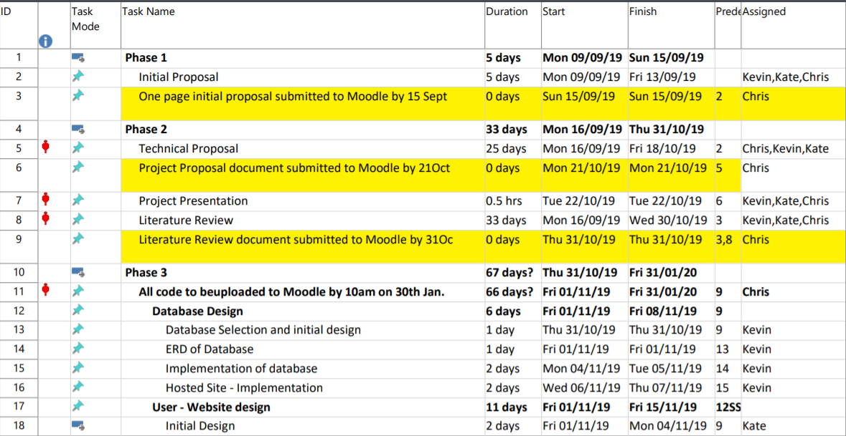
Figure 6. Phase 1, 2 and 3 features.
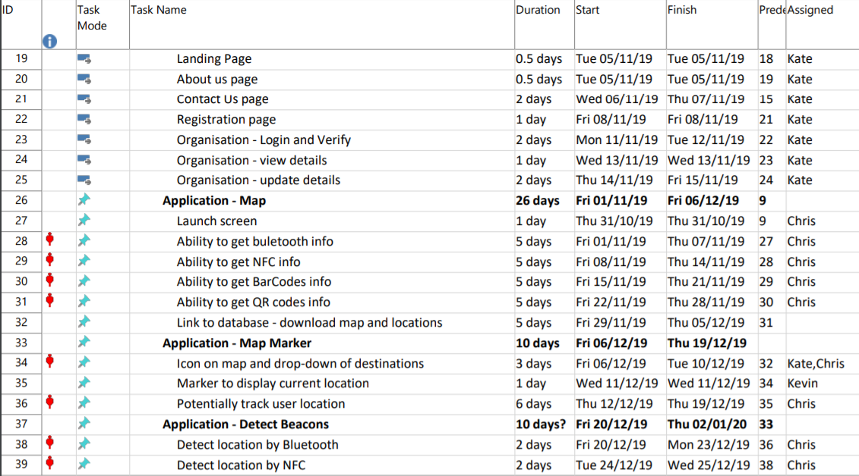
Figure 7. The Phase 3 functions and their breakdowns.
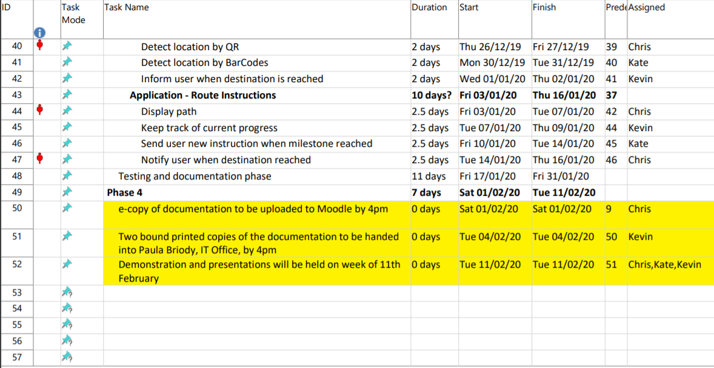
Figure 8. Phase 3 and 4 breakdown and final deadlines.
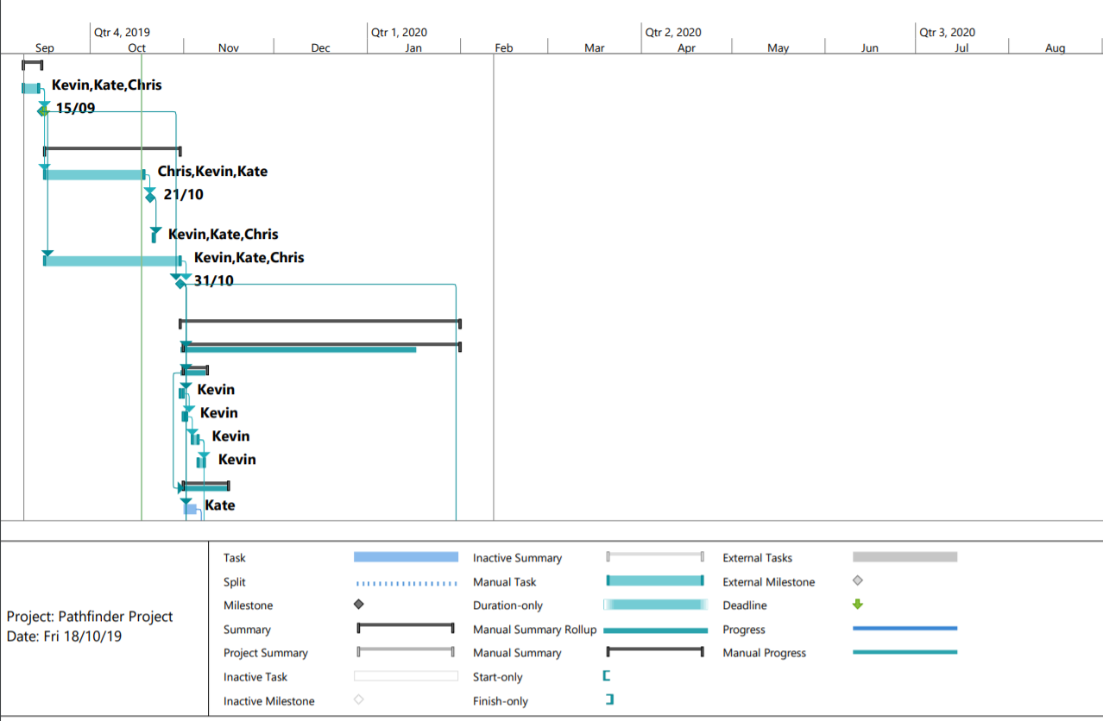
Figure 9. Visual representation of our schedule deadlines.
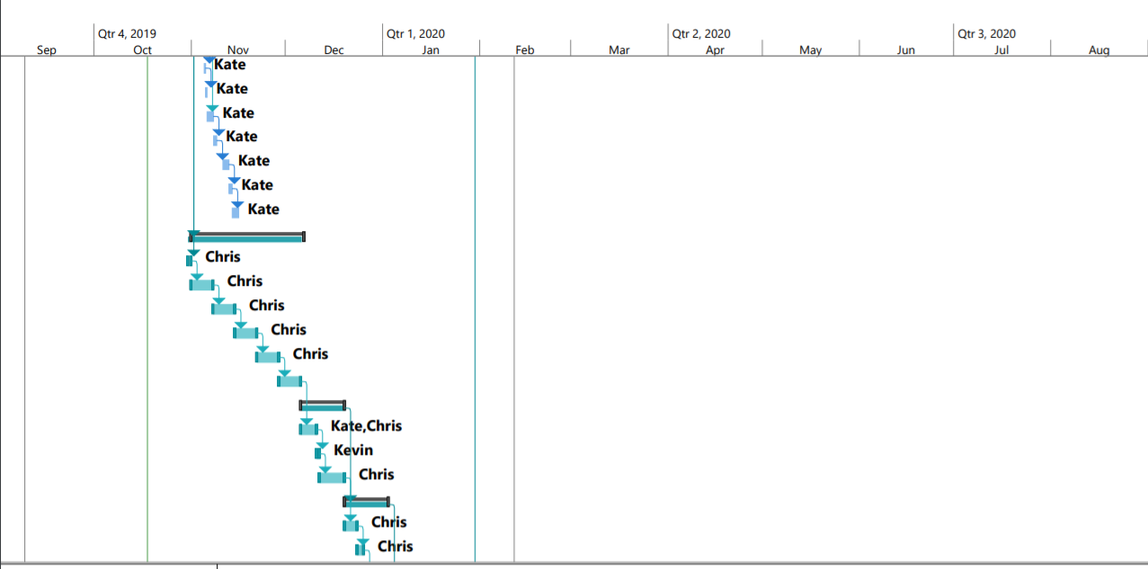
Figure 10. Visual representation of our schedule deadlines.

Appendix B
This is our excel spreadsheet with the features breakdown including sprints
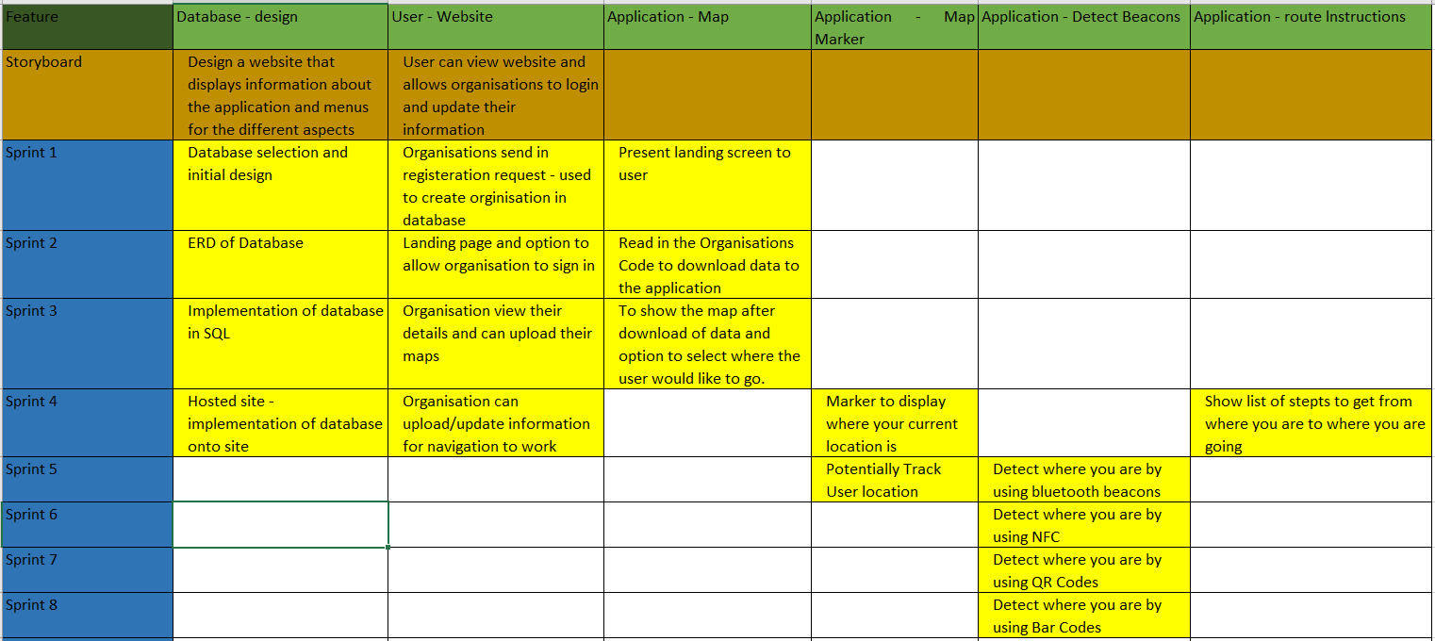
Figure 11. Feature Breakdown including Sprints.
This is our full feature breakdown structure.
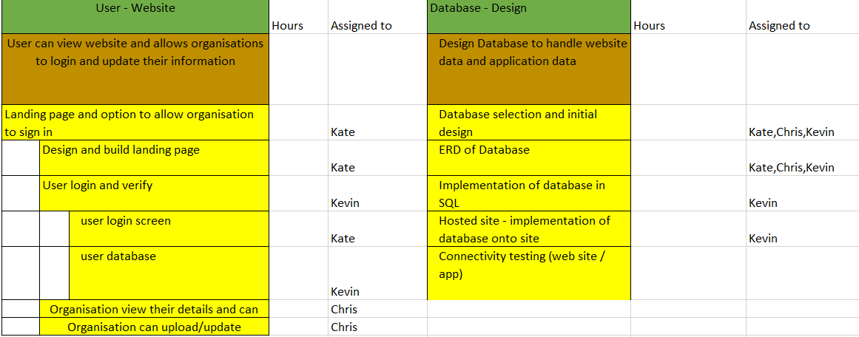
Figure 12. Part 1 of the FBS.
Figure 8. Part 1 of the FBS.
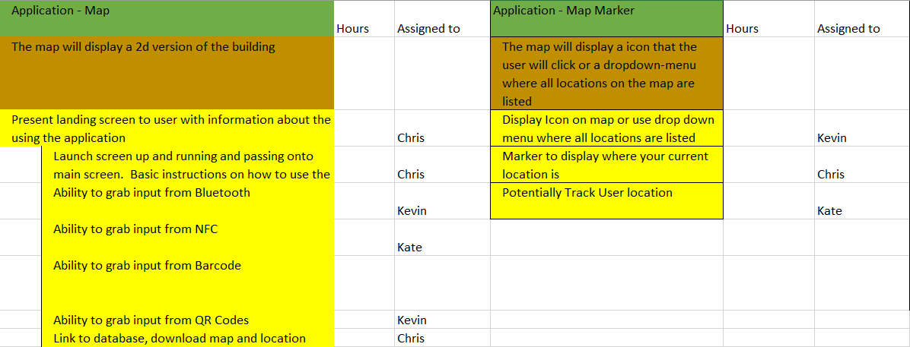
Figure 13. Part 2 of the FBS.
Figure 9. Part 2 of the FBS.
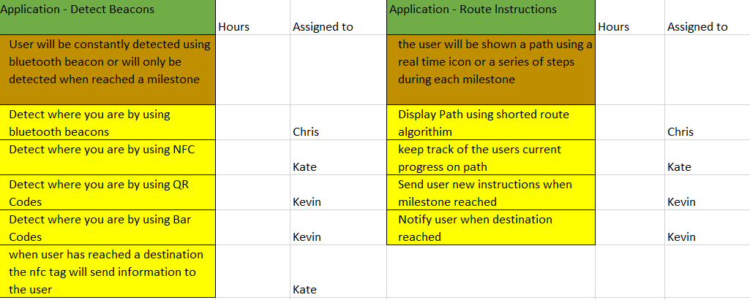
Figure 14. Part 3 of the FBS.

Appendix C
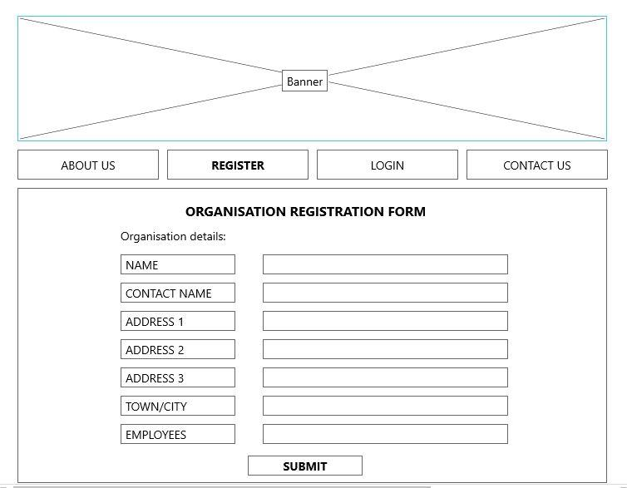
Figure 15. Registration Page.
This is the web page that the organization must fill up and submit to the creators of the application so that their organization is registered and can then use our application.
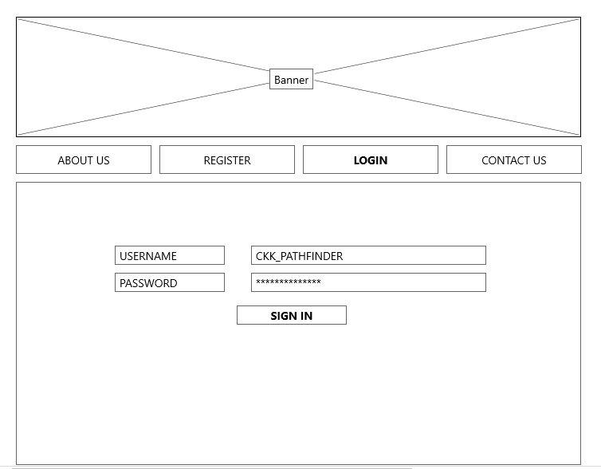
Figure 16. Login Page.
The login web page for the organization/user.
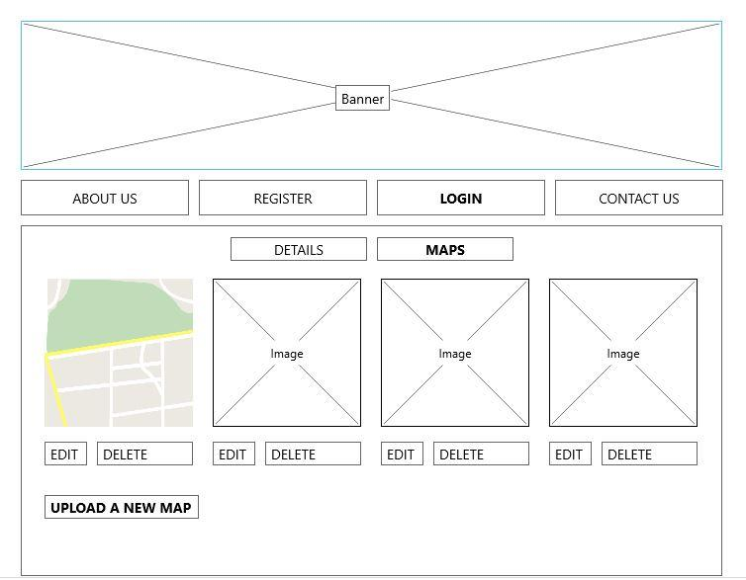
Figure 17. Maps uploading page.
This is the Maps section of our website which allows the organization to upload/edit and delete their maps.

Appendix D
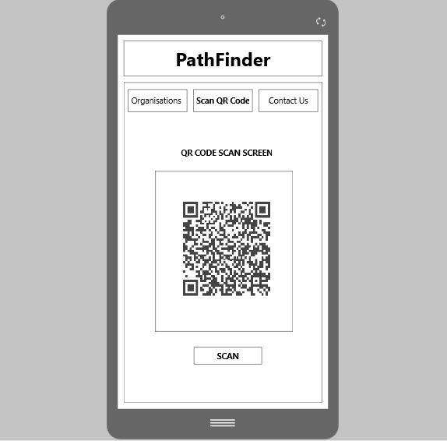
Figure 18. Android application QR codes scanner.
This will be the layout of the application when it needs to scan a QR code to find out the current location inside a building.
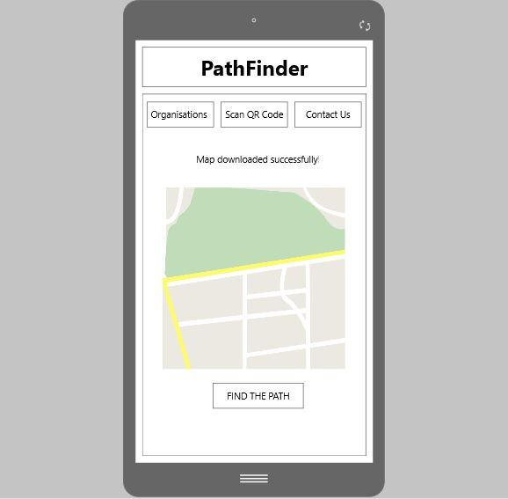
Figure 19. Downloading maps after scan.
This is the layout when a map has been successfully downloaded from our database and displayed to the user.
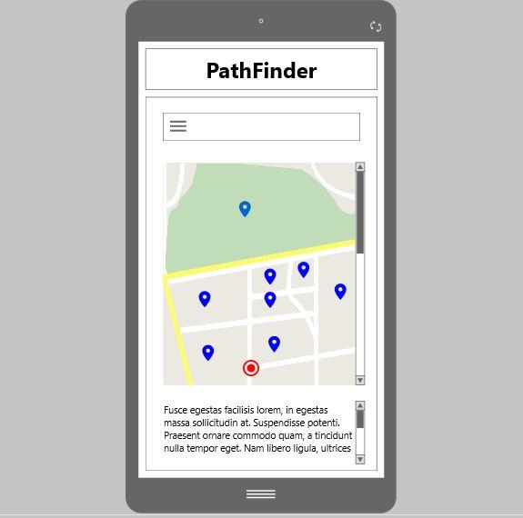
Figure 20. Route display.
This is the map of a building with different points on the map that the user can select.
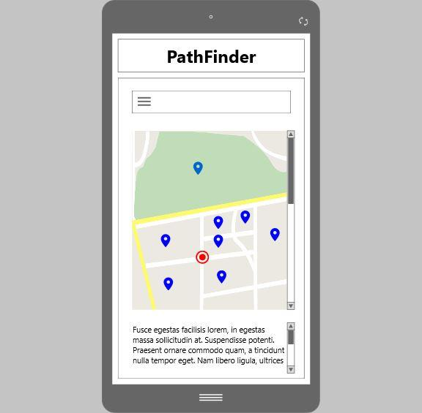
Figure 21. Moving at this route.
This is the map being updated with the user's current location.
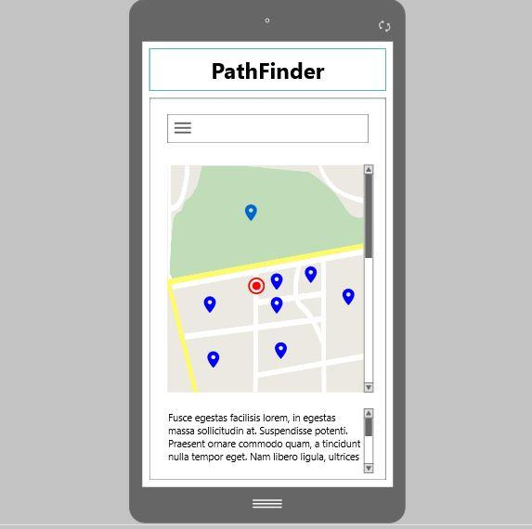
Figure 22. Moving to destination.
This is a display of the user’s current location.
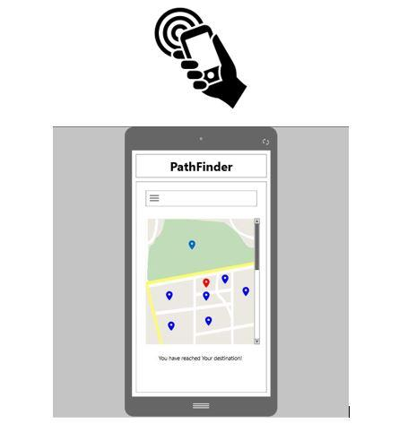
Figure 23. Reaching the destination.
This is the display on the map when the User has reached their current destination.

Student 1 Reflection
Contribution to the team – technical, project management, documentation deliverables
Reflection of that input to the team
1,500 – 3,000 words
Issues occurred in the group( describe at least 2)
How you felt working in the team
What you have learnt

Student 2 Reflection
As above..

Student 3 Reflection
As above..

Code (if appropriate)

Schematics (if appropriate)

User manual (where appropriate)
Write a concise but complete user manual or guide. This can be light on text so long as a novice user has enough information to use the application unaided.

